Maintenance
- There should be admin login, Change Password & forgot password
- Remove IIPC/EDP cell and add it under IQAC . Remove Membership form, Udyami Mitra & magazine from IQAC - completed
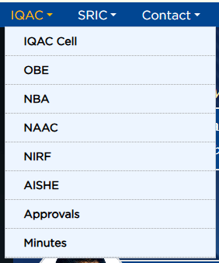
New Scope Of Work
- Notice should be dynamic - completed
- Quick links should be dynamic - completed
- Please add a button (Grievance) like Admission Enquiry in the left side of the page - completed
  - Name, Mobile,Email,Roll No, Brief of Grievance & upload
  - Save in admin panel and send mail to principal@gita.edu.in
- Syllabus should be dynamic (Yearwise) - completed
- Department of Faculties - completed
  - Name, Deg., Photo, Qulification, Mobile no and email.
- Alumni registration save in Admin panel - completed
- Seminar, Workshop, Research Paper - completed
- Placement should be dynamic - completed
- Login Urls should be dynamic - completed
- Fee structure should be dynamic – completed (client want it to export the data)
- Acedemic calender should be dynamic - completed
- Academic Holiday list should be dynamic
- Contact us page mobile no should be dynamic - completed
- There should be a popup “Thought of the Day ” - completed
- Photo Gallery should be dynamic- completed
- Chairman, Vice-Chairman, Secretary & Scholarship should be dynamic- completed
- How to update scholarship notice. - completed
- Add a new submenu under acdemics (Various Committee) upload the PDF shared before – menu added
- Academic Research data in a tabular form - completed
- Remove funding from Research - completed
- Make the course page yearwise
- Phd data will provide shortly
- For this section remove the priority and set as date wise - completed
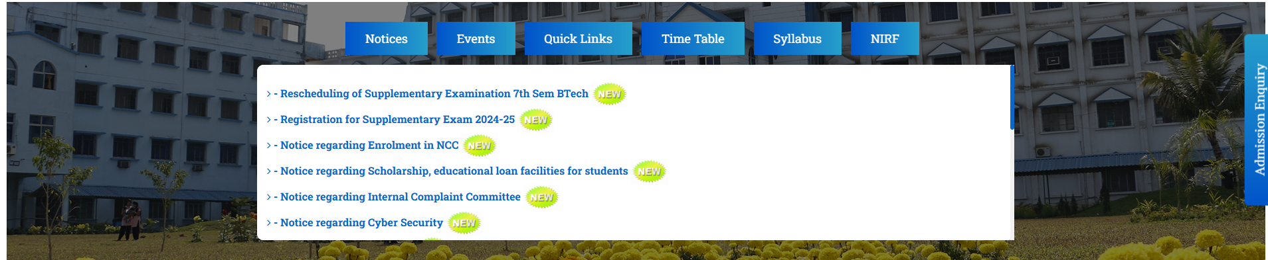
- Also add sub heading for this section.
- Make time table dynamic - completed
- Add CO-PO-Attainment below the CO-PO-mapping tab – only added the tab
Time required for above mentioned job – 80hr

